Measuring leaf area with ImageJ

Roman M. Link

April 2020

# Introduction

This is a simple tutorial for the measurement of leaf area with [ImageJ](https://imagej.nih.gov/ij/) based on [this great blog post](https://rookieecologist.wordpress.com/2016/11/21/how-to-measure-leaf-area-in-imagej/) which is meant for in-class use.

# Important note

All ImageJ results tables can be saved either in ‘Comma Separated Value’ (.csv) or whitespace/tabstop separated format (generated when saving with a .xls extension, but actually just a plain text format). In either case, the output is optimized for US/UK locales, which means that points are used as a decimal separator. In order to process these files on German systems without compatibility issues, it is important to make sure that the system-wide decimal separator is correctly set before starting the analysis.

In German Windows 10, the option to change the decimal separator is well hidden:

**Start Menu ➜ Windows-System ➜ Systemsteuerung ➜ Zeit und Region ➜ Region ➜ Formate ➜ Weitere Einstellungen ➜ Dezimaltrennzeichen**

To avoid data compatibility problems, make sure the decimal separator is set to “.”. In this case, you will want the grouping symbol (**Symbol für Zifferngruppierung**) to be a comma instead of the point symbol used in Germany.

If you do not want to change your system settings, you can alternatively export everything in a .csv format and use Excel’s **Daten ➜ Text in Spalten** menu to manually set field delimitor and decimal separator.

In addition, before you start with the analysis, make sure that the options for analyzing threshold images are correctly set. Go to **Process ➜ Binary ➜ Options** and make sure that the box **Black background** is not marked to avoid problems with the particle analysis macro.



# Step-by-step tutorial

1. Open the calibration file with ImageJ (drag and drop onto the program or use the Open dialogue). The calibration file should contain a size reference with a known length. In this example, the calibration file (prepared for the analysis with a different software) contained three paper squares of known area and side length, but in theory any reference of known dimensions will suffice (e.g. a ruler or millimeter paper).
2. To calibrate, Select the Straight line tool and trace the size reference (in the given example, I followed the outer margin of the largest square in the calibration file, which I knew to be 4 x 4 cm²).

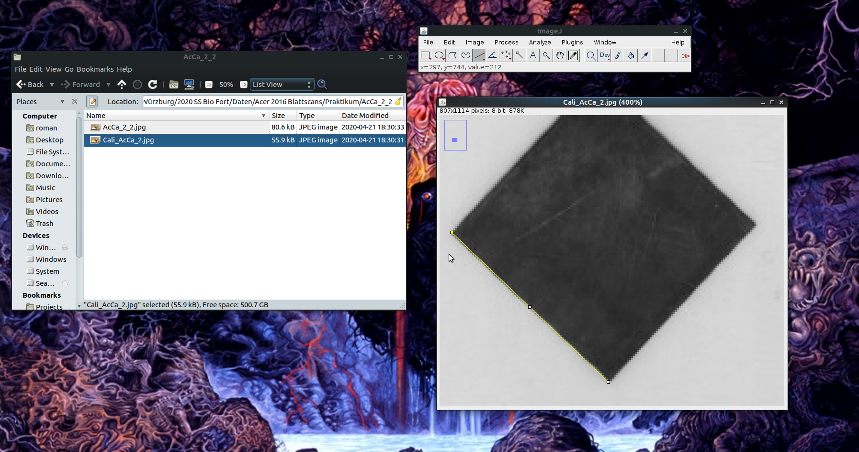

1. Set the scale by going to the **Analyze ➜ Set Scale** menu.
2. In the corresponding dialogue, set **Known Distance** to the known reference value (in this case, **4 cm**), the **Unit of length** to **cm** and - *very important* - mark the box **Global** to make sure that the scale is the same across all opened documents.

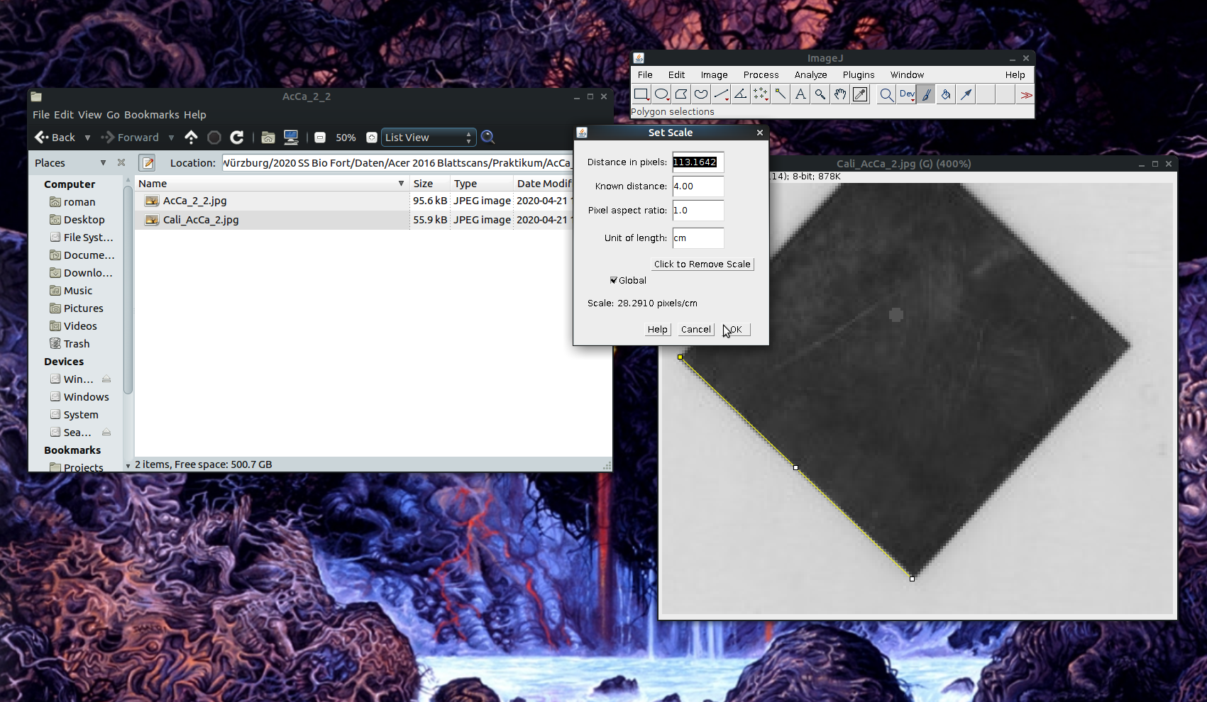

1. Open the file with the image you want to analyze in ImageJ (drag and drop!). If setting the scale worked, the size of the image should now be specified in cm in the upper right corner of the image. If a popup window opens asking you whether you want to keep the global calibration, say yes!

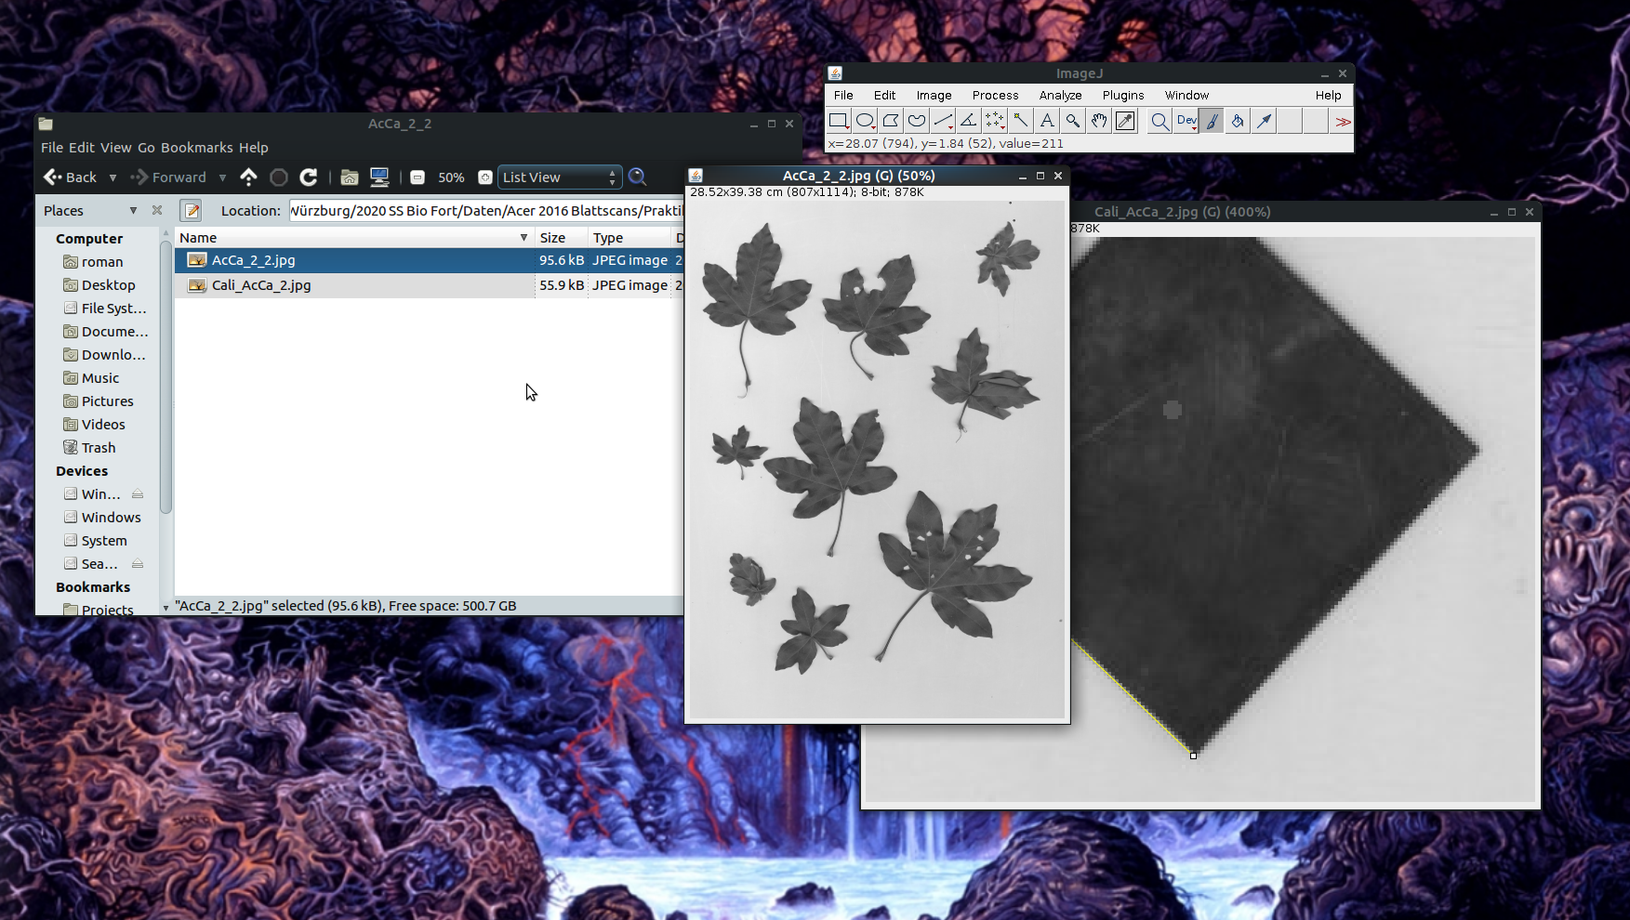

1. Make sure that the image is in an 8bit black and white format (click on **Image ➜ Type ➜ 8bit**) to avoid problems with thresholding.
2. Set a black/white threshold
   * Open the **Threshold** dialogue (**Image ➜ Threshold** or *Ctrl + Shift + T*),
   * Choose the options **Default** and **B&W** and uncheck the box **Dark background**,
   * If necessary, move the sliders until the leafs are well separated from the background with as few white pixels within the leaves as possible,
   * press **Apply** and close the **Threshold** window.

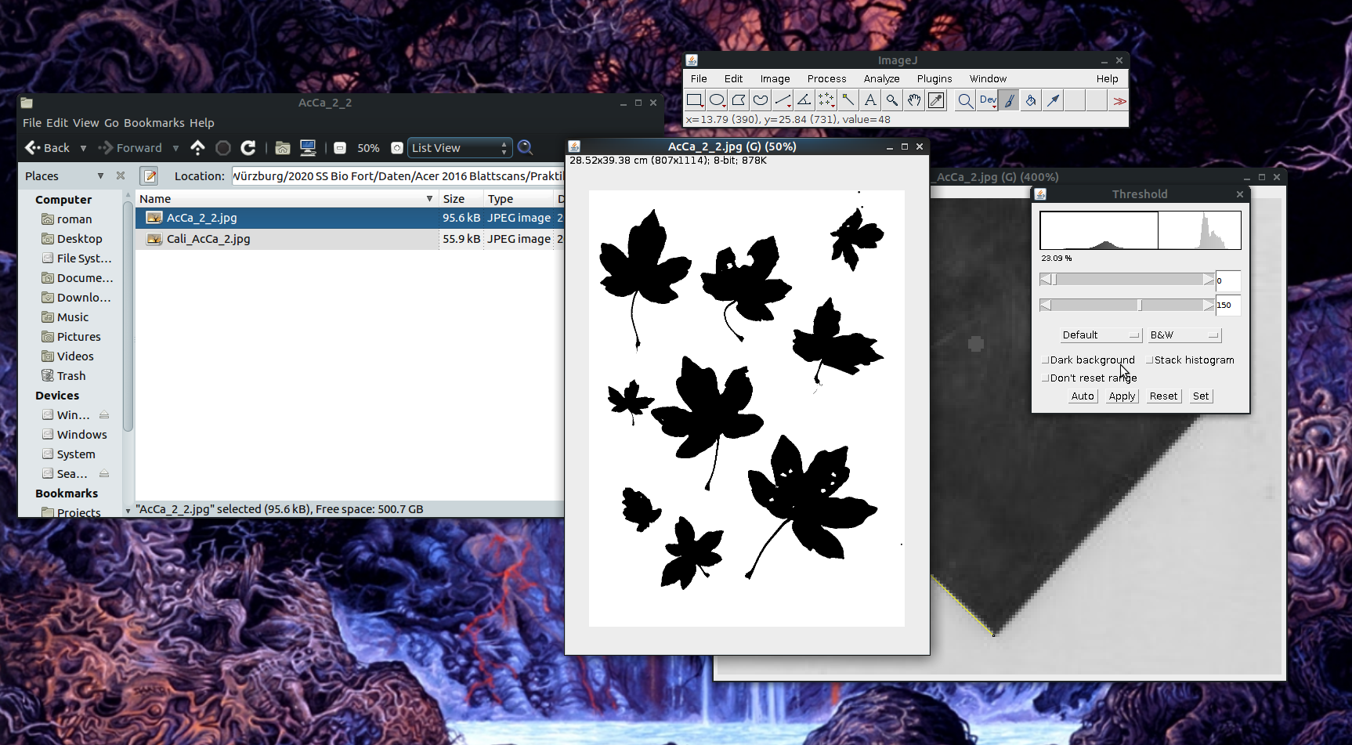

1. If there are holes in the leaves that connect with the leaf margins, pick the *Pipette* tool and click on a black area in the image. Holes that are in the middle of the leaf do not have to be fixed as they will not affect the measurement if the “Include holes” option is selected (see below).

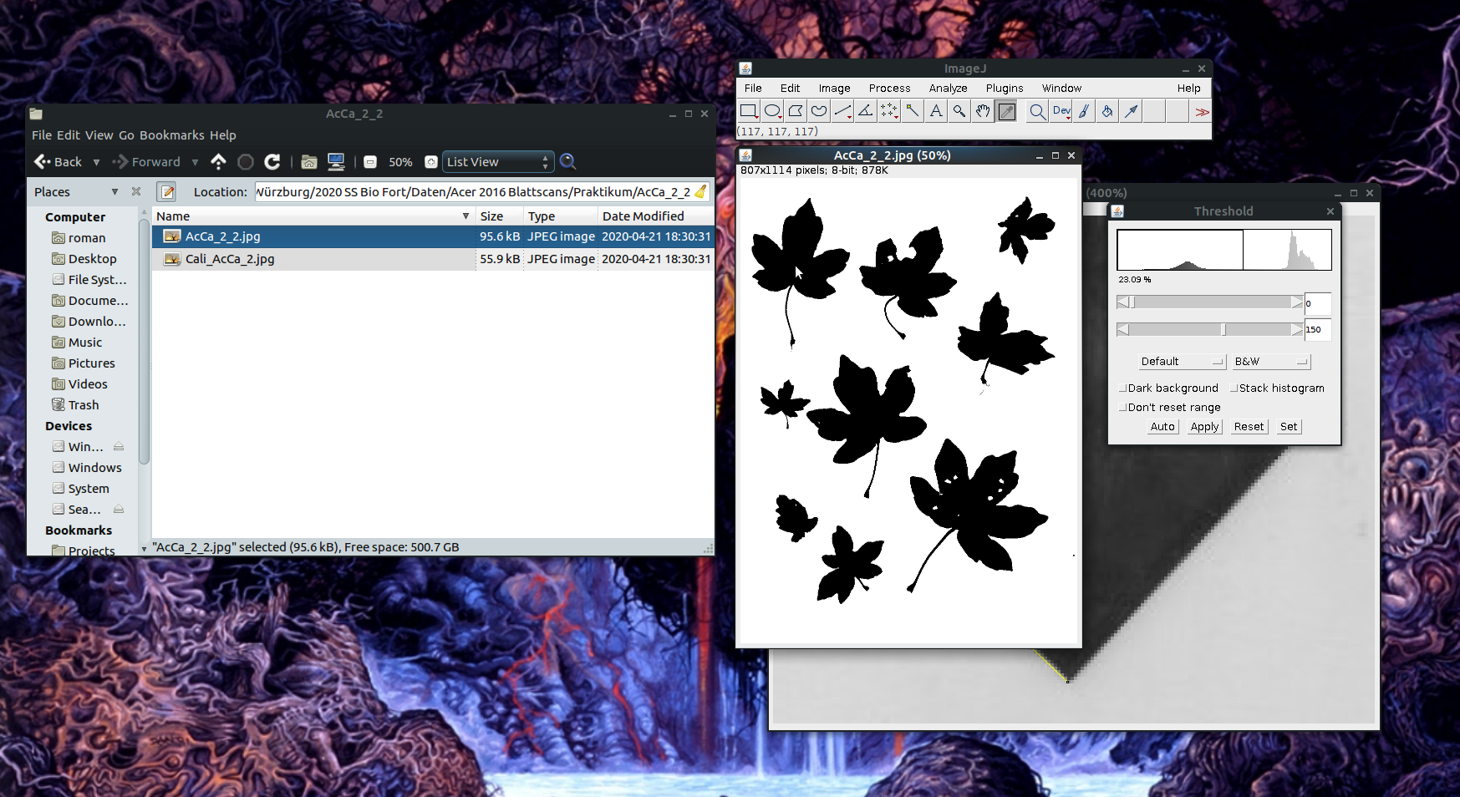

1. Now, choose the *Pencil tool* and close the holes manually (I closed all, but that’s not necessary).

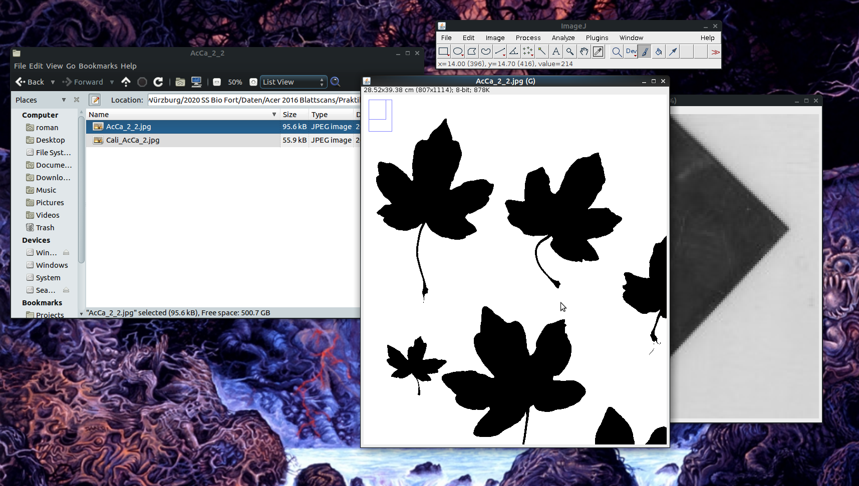

1. Open the set measurements dialogue (*Analyze ➜ Set Measurements*), uncheck everything besides *Area*, and click *OK*.

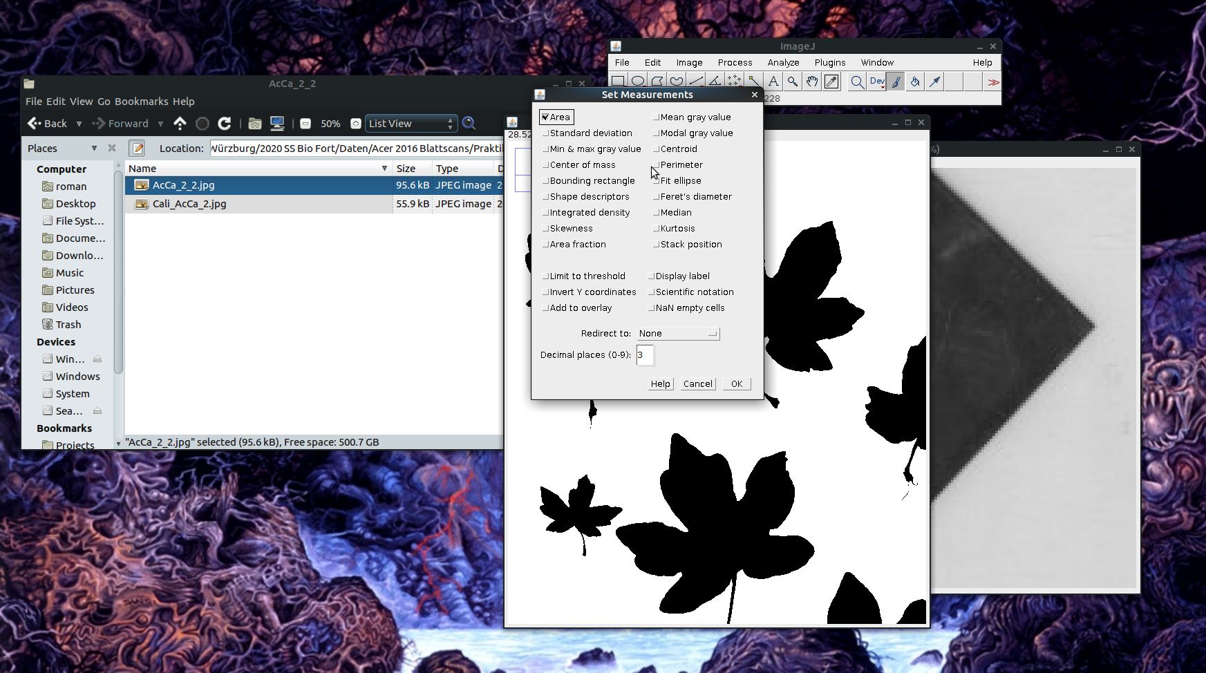

1. Open the *Analyze Particles* dialogue (*Analyze ➜ Analyze Particles*) and choose the following settings:

* *Size*: 0-Infinity [0 is chosen to demonstrate the effect of a small minimum value (see next points) - in most cases it makes sense to start from 1-Infinity right away]
* *Roundness*: 0-1
* Show: Outlines
* Check *Display results*, *Clear results* and *Include holes* (if there is more than one scan per sample, it can also be a good idea *not* to choose *Clear results* to be able to combine the measurements of all scans and save all results together in a single file)

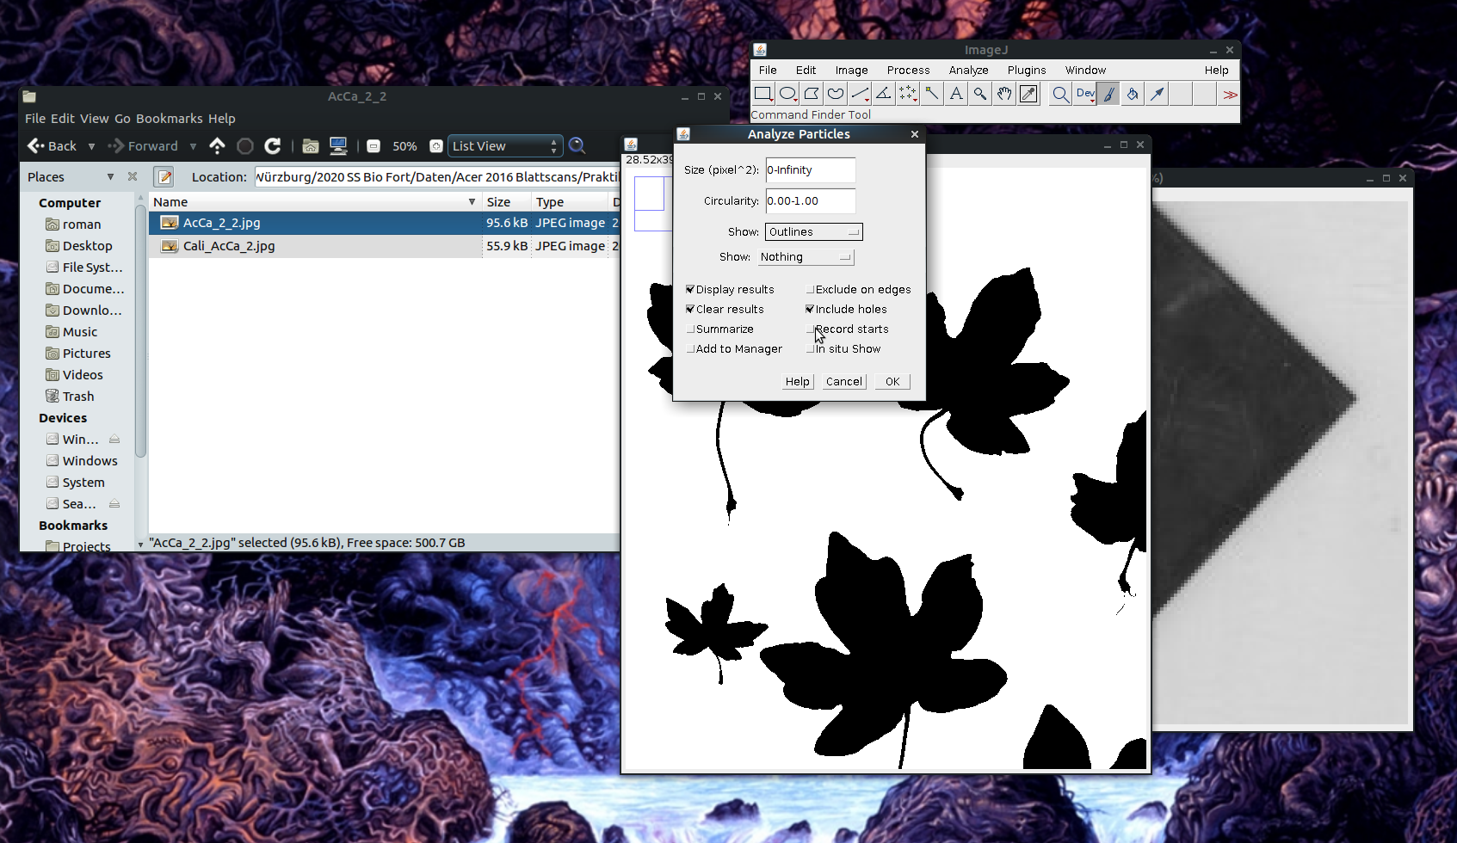

1. Look at the outlines to check if non-leaf particles were measured.

* Solutions if there are small non-leaf particles:
  + Use the pencil tool to remove small artefacts
  + Use the rectangle tool (left end of the toolbar) to choose a subset of the Image area (useful if there are shading artefacts near the borders)
  + Repeat the *Analyze Particles* step with a different minimum value for *Size*

*initial run:* 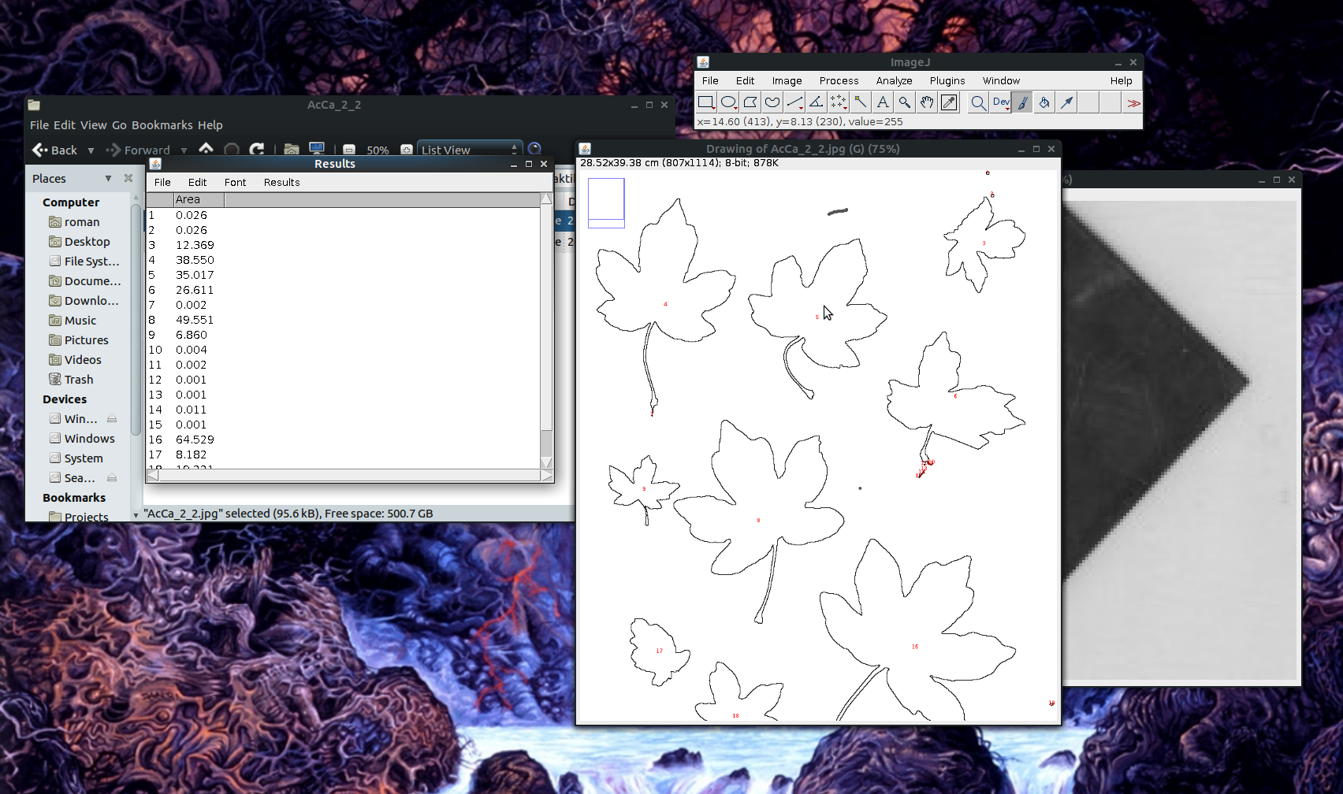

*after setting Size to 1-Infinity cm²:* 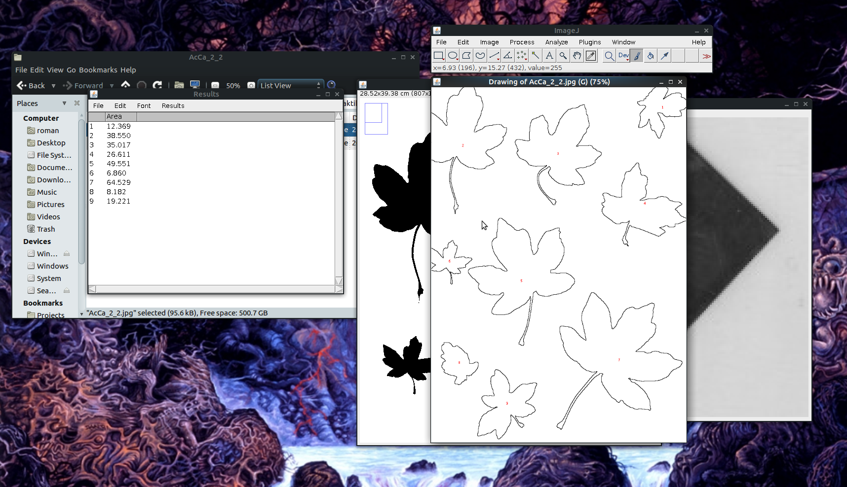

1. Click on the outline file and choose *File ➜ Save as ➜ Jpeg* in the main window to save it (append the original filename to name_outlines.jpg)
2. Choose *File ➜ Save as* in the Results window to save the leaf area measurements as name_results.xls.
3. Your project folder should look like this now:

